

WellNYS Everyday

March 2025 Wellness Webinar

**Innovative Approaches to Healthy Eating**



**Monday, March 10, 2025**

**12:00 noon – 12:25 p.m.**

Join us as we share the March WellNYS Weekly Challenges and focus on innovative approaches to healthy eating such as reducing your portion, reducing sugar, and creative ways to eat mindfully. This webinar will include things to say to yourself if you eat too fast, tips to curve sugar cravings, and the easiest meal to cut in half.

Have something delicious to eat to participate in a mindful eating activity.

[Register](https://meetny-gov.webex.com/weblink/register/r31d16e0293372b3badbb76e09a361a1d)

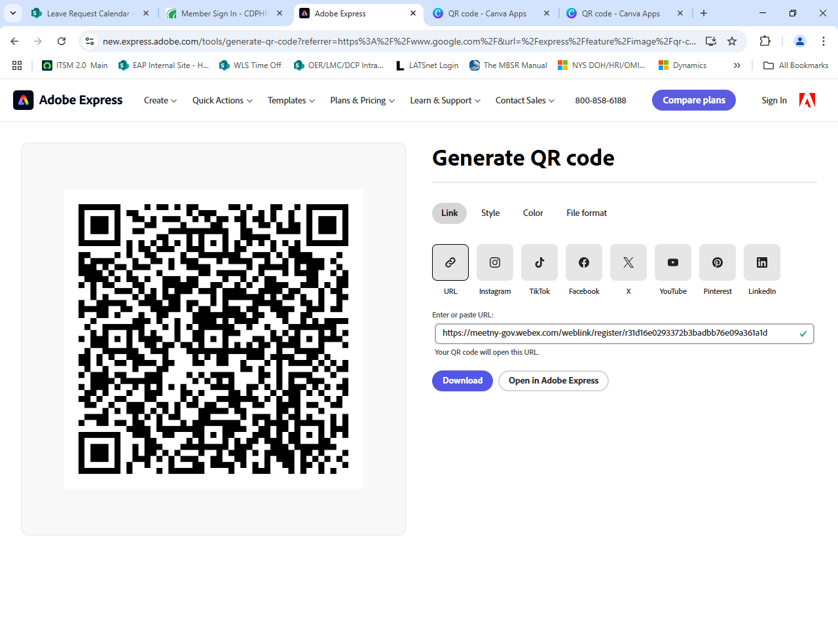

If you are unable to attend live, this webinar will be recorded and put on the WellNYS Everyday website.

WellNYS Everyday is a wellness initiative dedicated to educating, engaging, and empowering New York State employees to engage in healthy behaviors. For more information, visit [oer.ny.gov/wellnys/everyday](https://oer.ny.gov/wellnys-everyday)